Assignment_1
2026-09-09
dataset from https://www.epa.gov/outdoor-air-quality-data/download-daily-data
my_data <- read.csv("air_data.csv")
head(my_data)
## Date Source Site.ID POC Daily.Max.8.hour.CO.Concentration Units
## 1 01/01/2026 AQS 390350051 1 0.2 ppm
## 2 01/02/2026 AQS 390350051 1 0.3 ppm
## 3 01/03/2026 AQS 390350051 1 0.3 ppm
## 4 01/04/2026 AQS 390350051 1 0.3 ppm
## 5 01/05/2026 AQS 390350051 1 0.7 ppm
## 6 01/06/2026 AQS 390350051 1 0.6 ppm
## Daily.AQI.Value Local.Site.Name Daily.Obs.Count Percent.Complete
## 1 2 Galleria 19 79
## 2 3 Galleria 24 100
## 3 3 Galleria 24 100
## 4 3 Galleria 24 100
## 5 8 Galleria 24 100
## 6 7 Galleria 24 100
## AQS.Parameter.Code AQS.Parameter.Description Method.Code CBSA.Code
## 1 42101 Carbon monoxide 54 17460
## 2 42101 Carbon monoxide 54 17460
## 3 42101 Carbon monoxide 54 17460
## 4 42101 Carbon monoxide 54 17460
## 5 42101 Carbon monoxide 54 17460
## 6 42101 Carbon monoxide 54 17460
## CBSA.Name State.FIPS.Code State County.FIPS.Code County
## 1 Cleveland-Elyria, OH 39 Ohio 35 Cuyahoga
## 2 Cleveland-Elyria, OH 39 Ohio 35 Cuyahoga
## 3 Cleveland-Elyria, OH 39 Ohio 35 Cuyahoga
## 4 Cleveland-Elyria, OH 39 Ohio 35 Cuyahoga
## 5 Cleveland-Elyria, OH 39 Ohio 35 Cuyahoga
## 6 Cleveland-Elyria, OH 39 Ohio 35 Cuyahoga
## Site.Latitude Site.Longitude
## 1 41.5046 -81.69045
## 2 41.5046 -81.69045
## 3 41.5046 -81.69045
## 4 41.5046 -81.69045
## 5 41.5046 -81.69045
## 6 41.5046 -81.69045
In this step, I loaded the cleaned EPA air quality dataset and generated descriptive statistics to examine the central tendencies, spread, and distributions of both quantitative and categorical variables.
summary(my_data[c("Daily.Max.8.hour.CO.Concentration", "Daily.AQI.Value", "Source")])
## Daily.Max.8.hour.CO.Concentration Daily.AQI.Value Source
## Min. :0.1000 Min. : 1.000 Length:633
## 1st Qu.:0.2000 1st Qu.: 2.000 Class :character
## Median :0.3000 Median : 3.000 Mode :character
## Mean :0.4169 Mean : 4.695
## 3rd Qu.:0.5000 3rd Qu.: 6.000
## Max. :2.6000 Max. :30.000
The summary output reveals key metrics for our quantitative pollutant data, including the minimum, 1st quartile, median, mean, 3rd quartile, and maximum values. These figures highlight the overall concentration levels and signal any potential outliers or missing data. Additionally, frequency counts for categorical variables summarize how observations are distributed across different monitoring sites and region classifications.
To fulfill the variable transformation requirement, I created a new calculated column named CO_doubled by taking the original Carbon Monoxide (CO) measurements and scaling them by a factor of 2 (air_data$CO_{d}oubled<−air_{d}ata$CO * 2).
my_data$CO_doubled <- my_data$Daily.Max.8.hour.CO.Concentration * 2
head(my_data[c("Daily.Max.8.hour.CO.Concentration", "CO_doubled")])
## Daily.Max.8.hour.CO.Concentration CO_doubled
## 1 0.2 0.4
## 2 0.3 0.6
## 3 0.3 0.6
## 4 0.3 0.6
## 5 0.7 1.4
## 6 0.6 1.2
Printing the first few rows of the updated dataset confirms that the mathematical operation applied correctly across all observations. The CO_doubled column maintains the structure of the original data while reflecting the scaled values, demonstrating how derived metrics can be generated in R for further modeling or baseline adjustments.
To visually inspect the distribution and trends within the EPA air quality dataset, I constructed a plot using R’s visualization tools. This graph maps out key pollutant observations to help identify patterns, variance, and potential relationships across monitoring data points.
hist(my_data$Daily.AQI.Value, main="AQI Distribution", xlab="AQI")
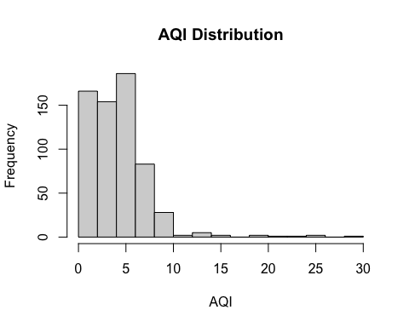
plot(my_data$Daily.Max.8.hour.CO.Concentration, my_data$Daily.AQI.Value, xlab="CO Concentration", ylab="AQI")
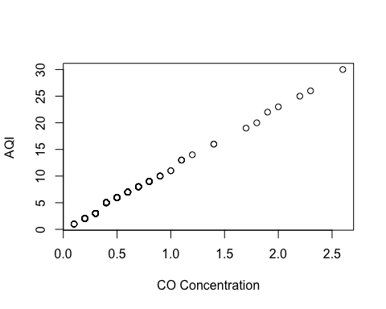 The generated plot provides a clear visual summary of the data distribution. By mapping the variable values, we can quickly observe central clustering, peak concentration events, and any extreme values that stand out from the baseline. This visual check complements our numerical summary statistics and confirms that the dataset structure is suitable for further analysis.

